Phase 5 part d
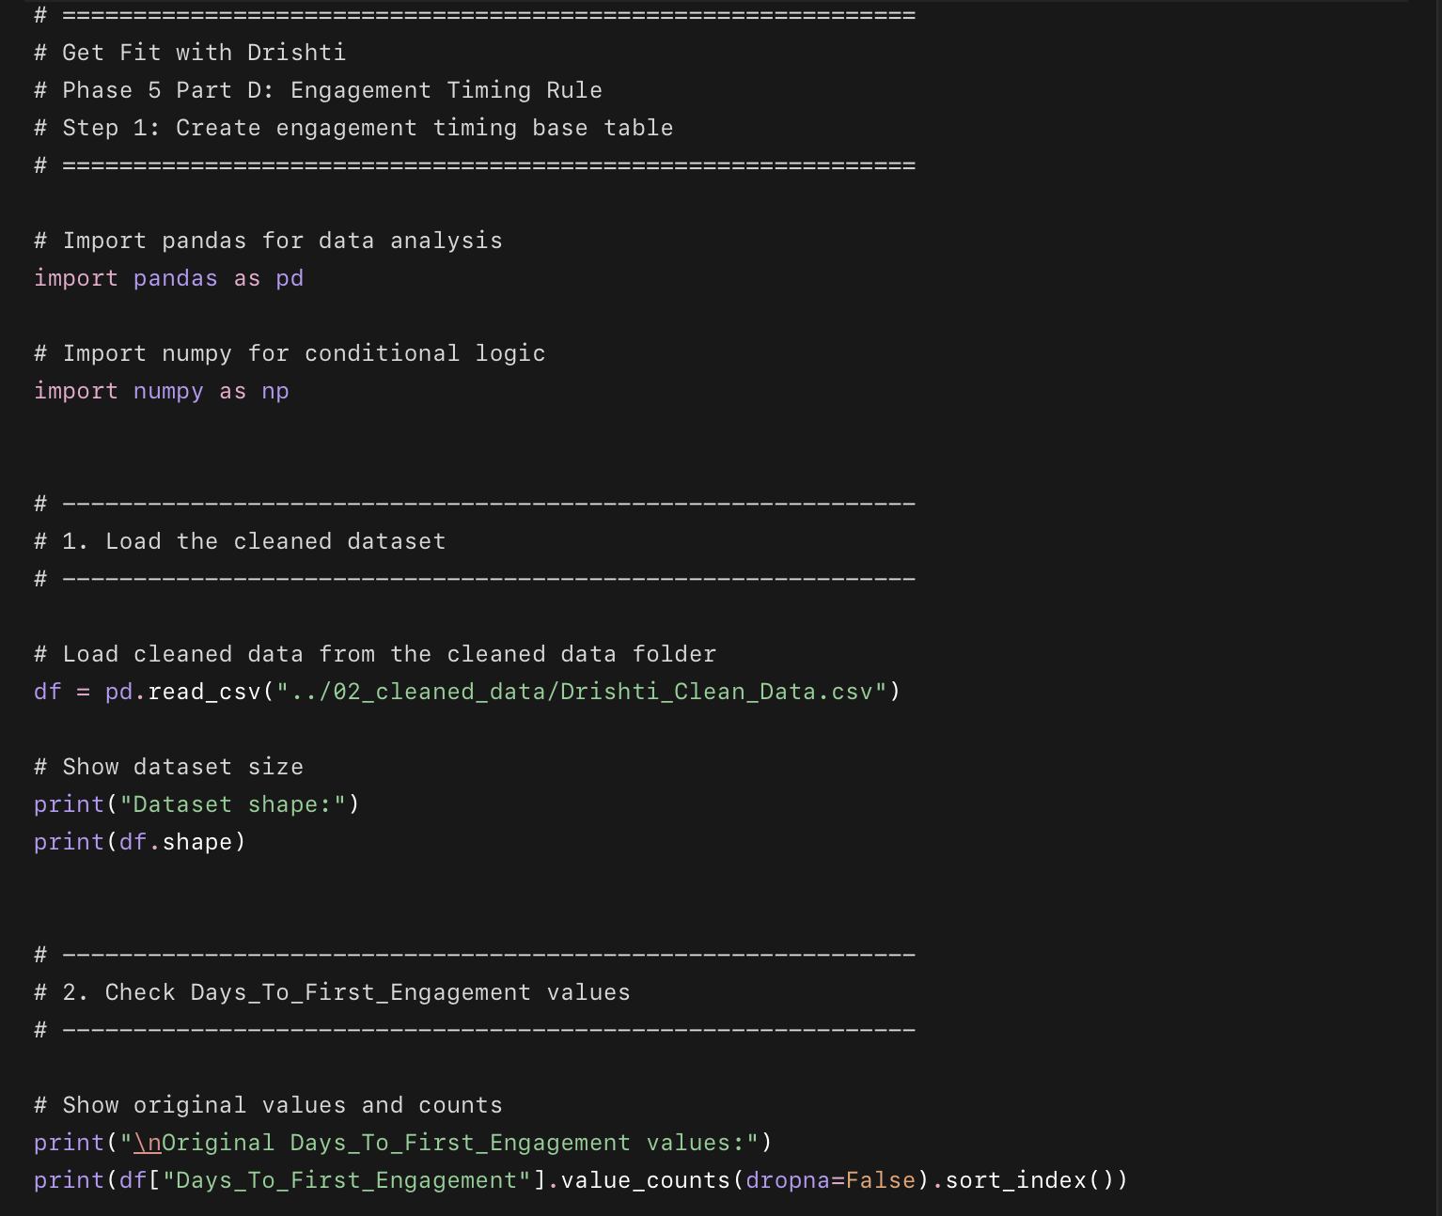
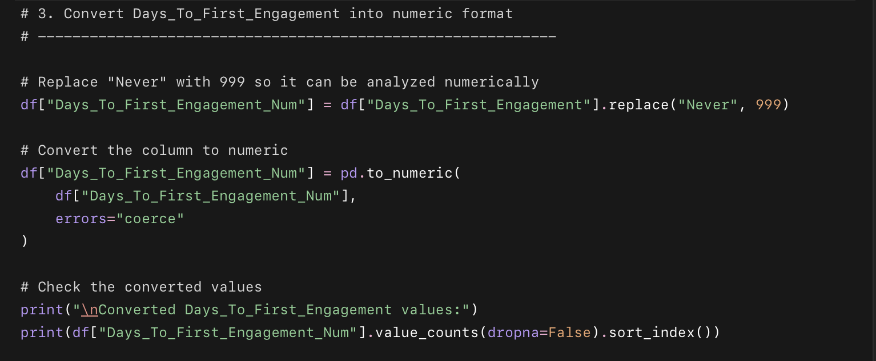
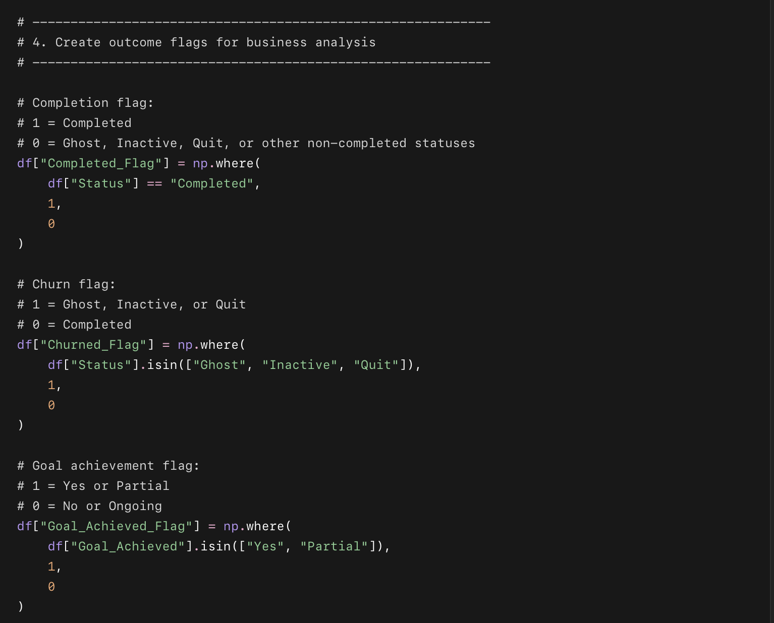
- 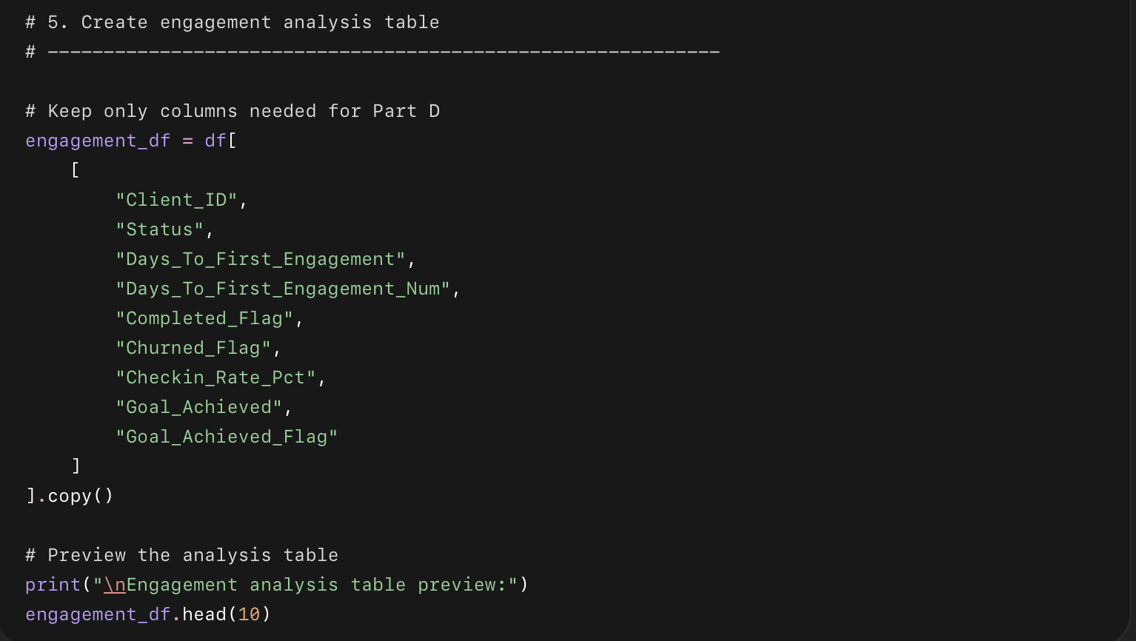 Loads the cleaned dataset.
- Checks the original Days_To_First_Engagement values.
- Converts "Never" into 999.
- Creates business outcome flags:
  - completed or not
  - churned or not
  - achieved goal or not
- Creates a clean engagement_df table for Part D analysis.

Why we are doing this
Before finding the engagement threshold, we need a clean numeric version of first engagement timing. This lets us compare completion rate, churn rate, check-in rate, and goal achievement rate by engagement delay.
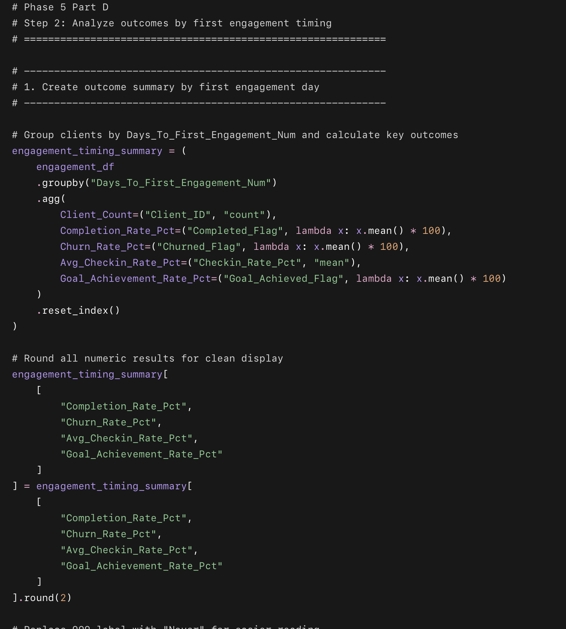
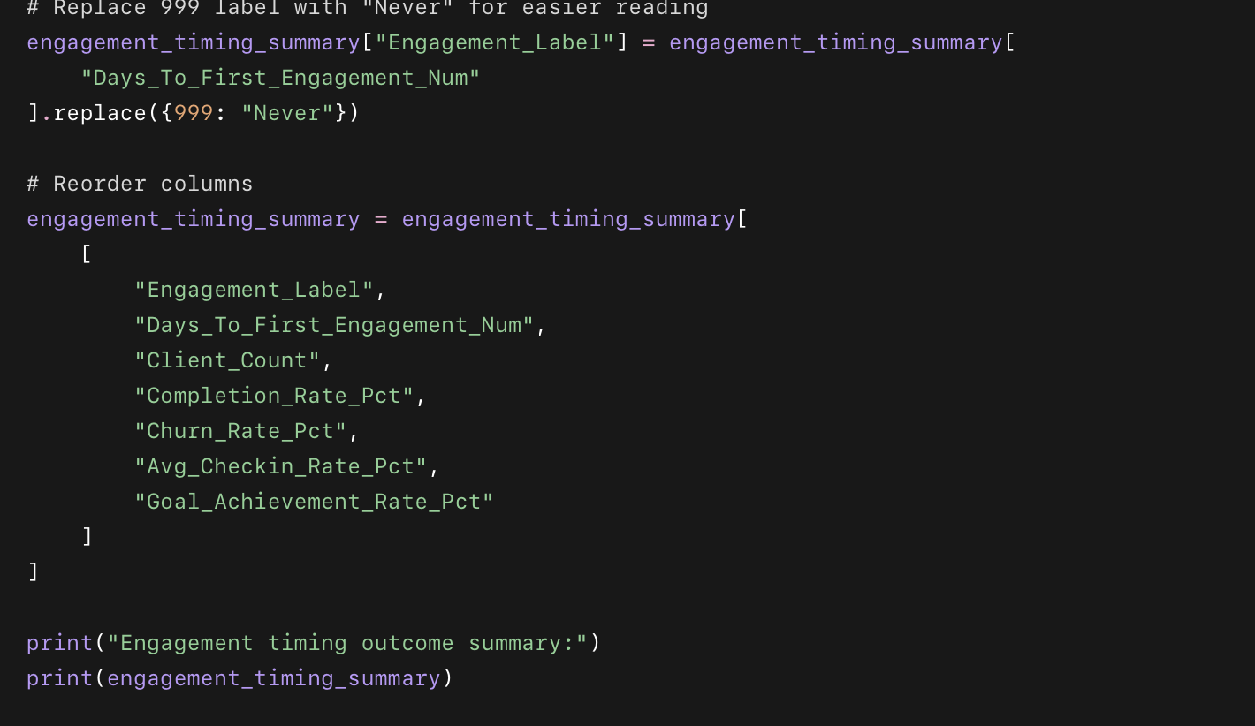
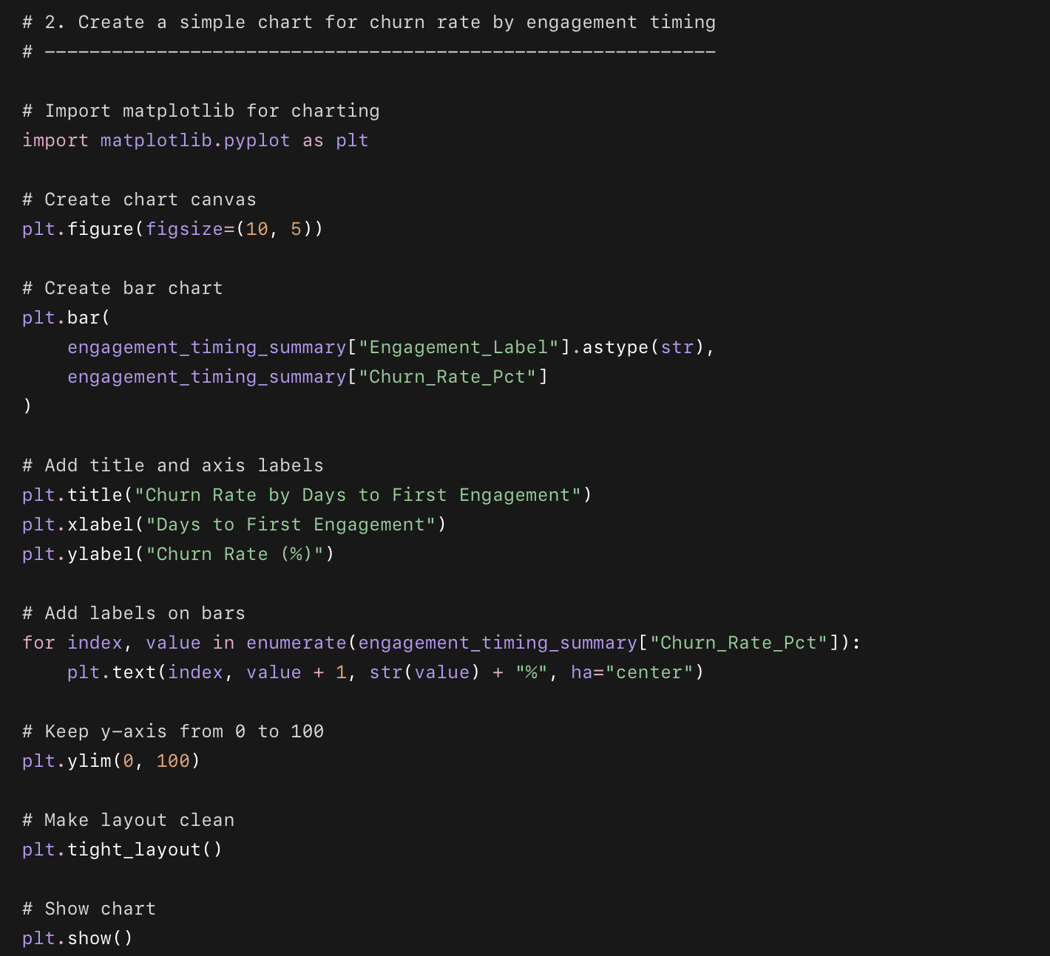

What this code does
- Groups clients by first engagement timing.
- Calculates:
  - completion rate
  - churn rate
  - average check-in rate
  - goal achievement rate
- Creates a summary table.
- Creates a churn-rate chart by first engagement day.

Why we used this code
This helps us see whether delayed first engagement is connected to worse client outcomes. The churn chart will help us visually find when dropout risk starts increasing.

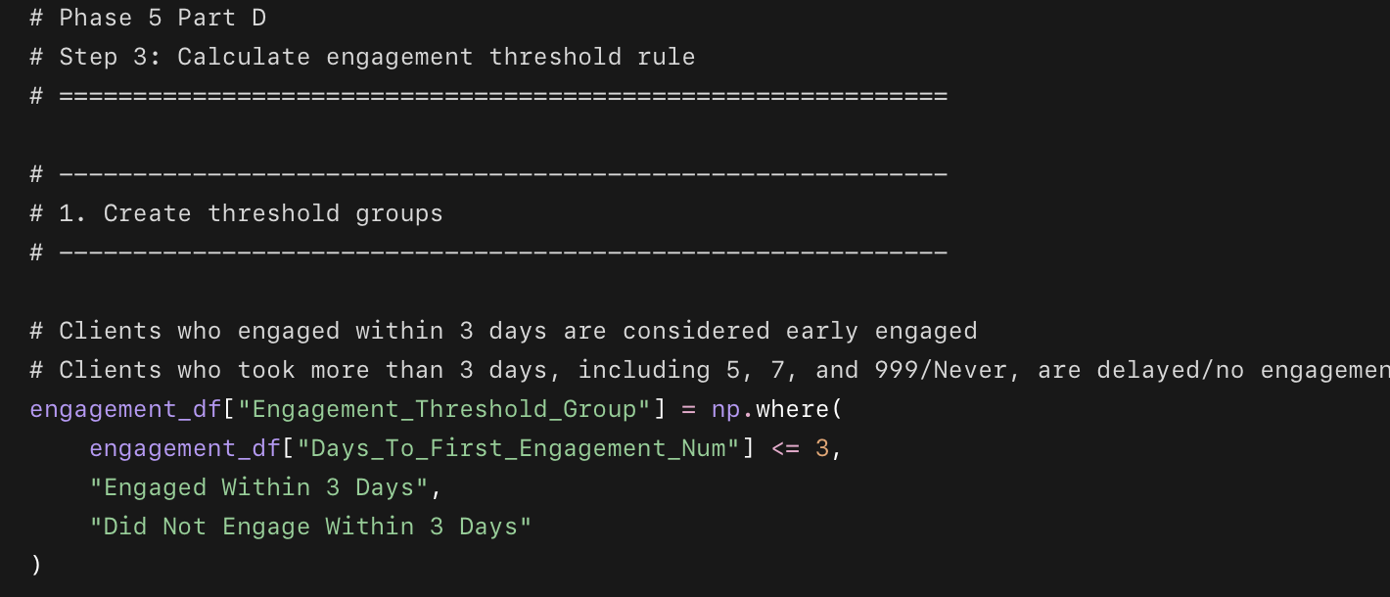
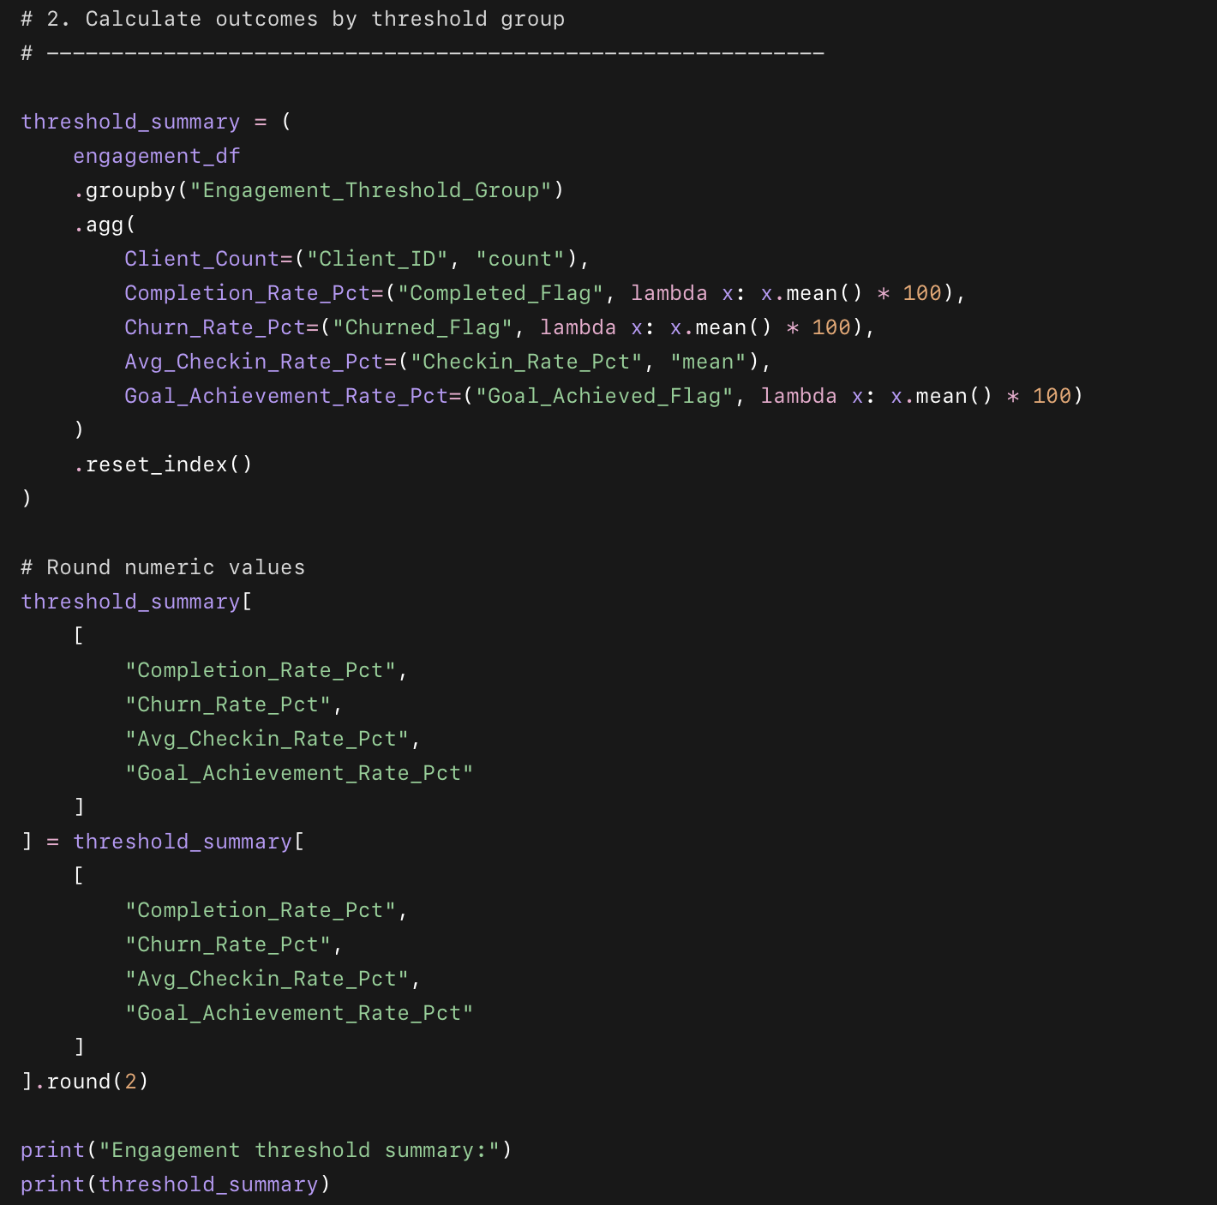
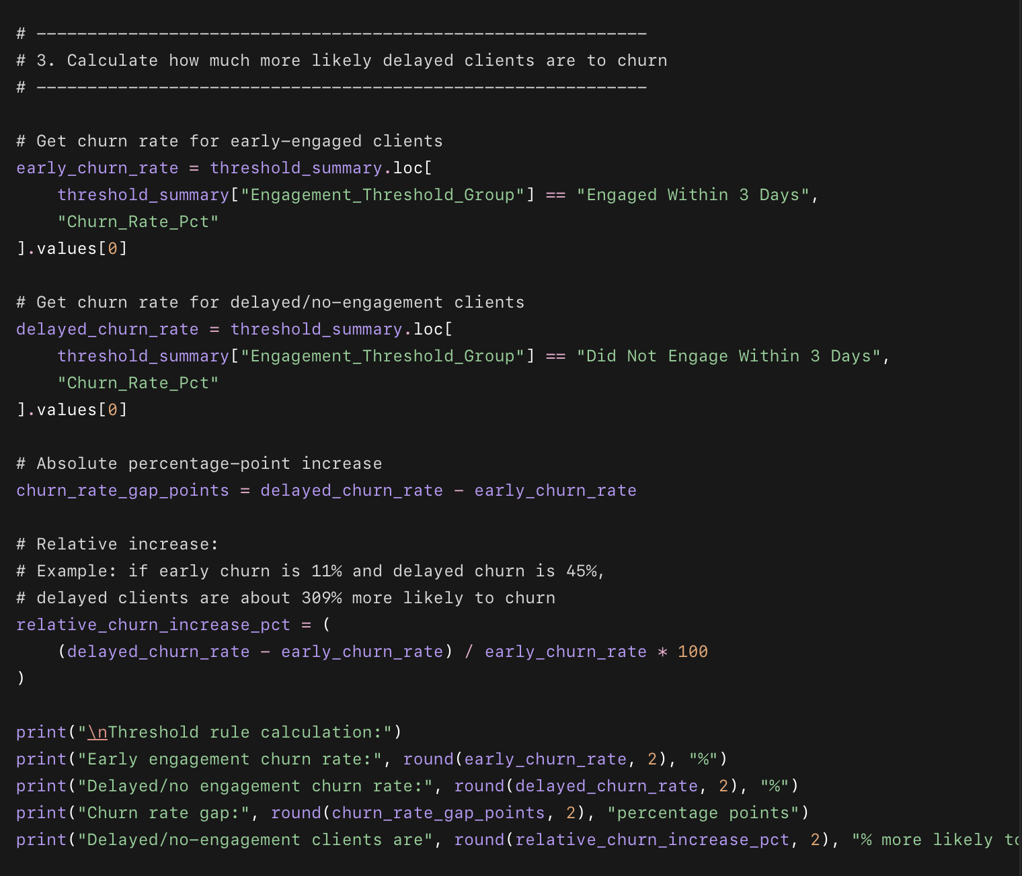drop out.”
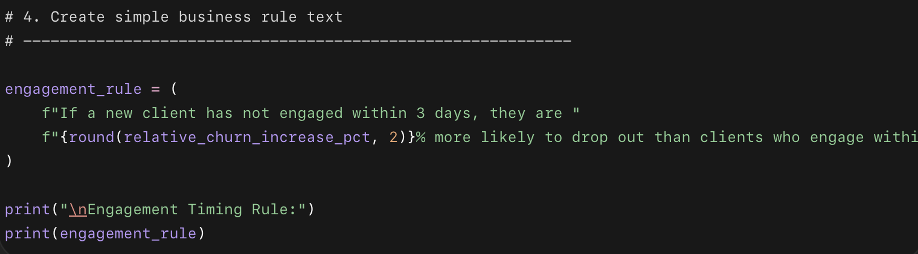 within 3 days.”

What this code does
- Creates two groups:
  - clients who engaged within 3 days
  - clients who did not engage within 3 days
- Calculates completion, churn, check-in, and goal achievement rates for both groups.
- Calculates the exact difference in churn risk.
- Creates a simple business rule sentence.

Why we used this code
This turns the engagement timing analysis into a clear operating rule. Drishti does not need to read a full chart every week — she just needs to know when to intervene.

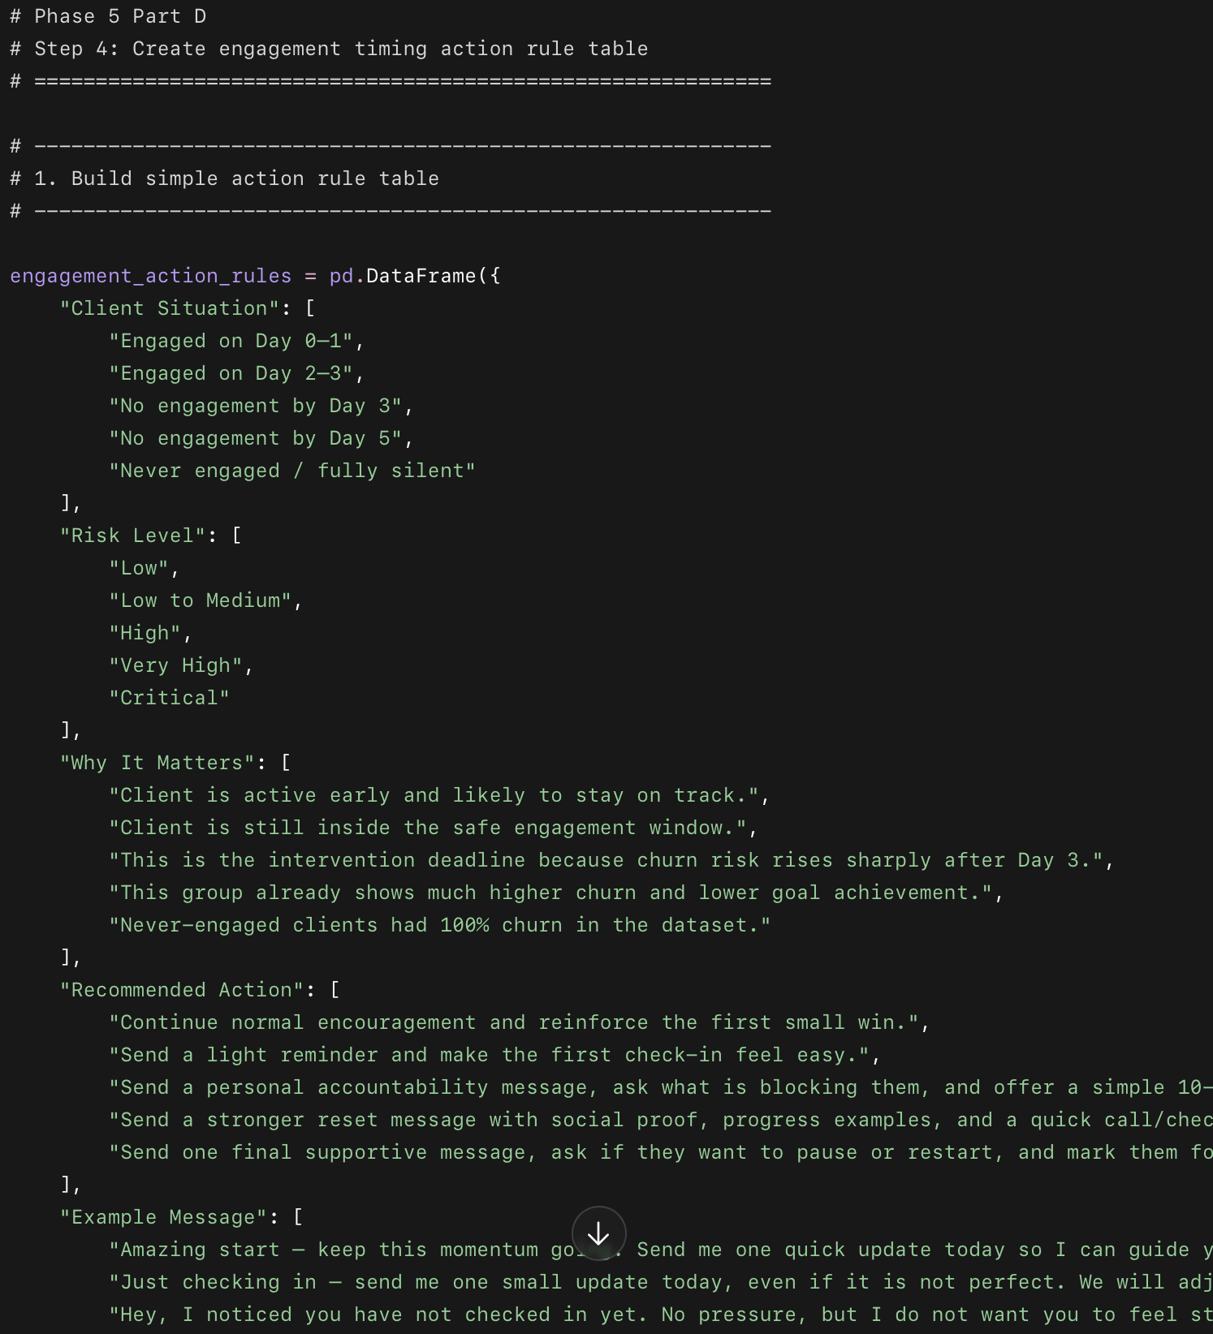
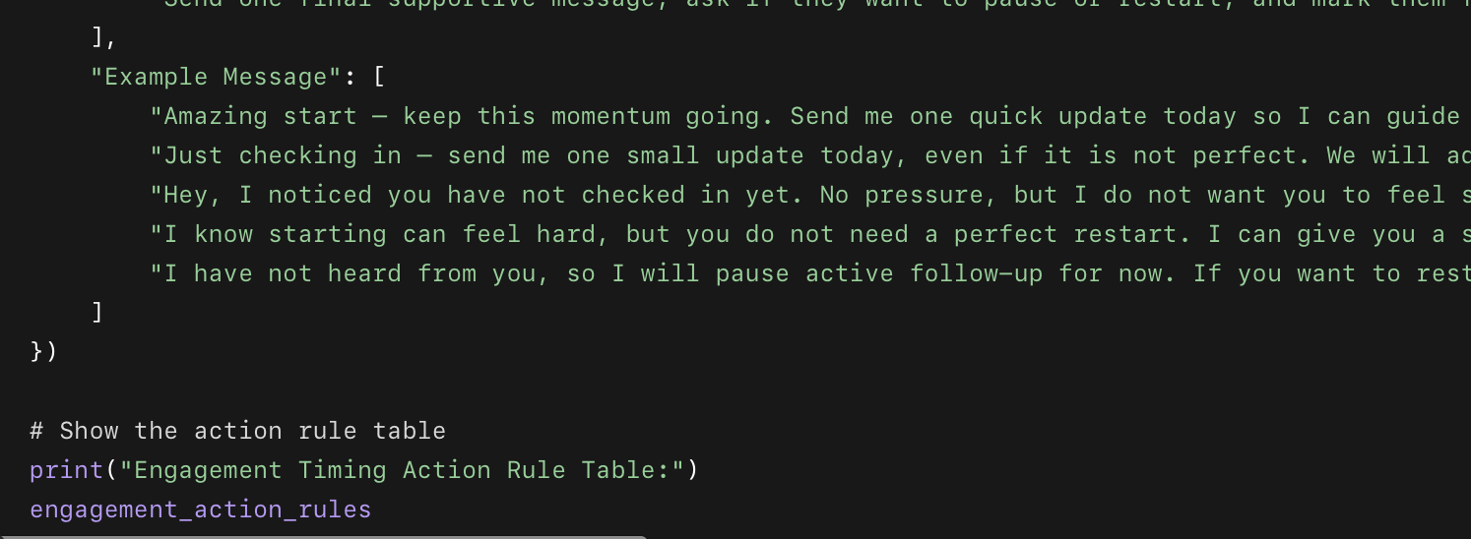

What this code does
- Creates a simple action table for Drishti.
- Turns the Day 3 threshold into a daily follow-up system.
- Gives risk levels for different engagement situations.
- Adds specific recommended actions.
- Adds example messages Drishti can use or customize.

Why we used this code
The analysis is only useful if it becomes action. This table turns the churn insight into a weekly operating system that tells Drishti exactly when and how to follow up.

